I would like a trial by combat. King in the North. The battle of the redgrass field. May the Father judge him justly. The bear and the maiden fair. You know nothing, Jon Snow. A Lannister always pays his debts. I pledge my life and honor to the Night's Watch, for this night and all the nights to come. Pay the iron price. House Tarly of Horn Hill The North remembers. When you play the game of thrones, you win or you die. The tourney of Ashford Meadows. The night is dark and full of terrors. The night is dark and full of terrors. A dream of Spring. Dunc the Lunk, thick as a castle wall. The Knight of Lemonwood. I pledge my life and honor to the Night's Watch, for this night and all the nights to come. A good act does not wash out the bad, nor a bad act the good. Each should have its own reward. What is dead may never die. The wolf and the lion. A good act does not wash out the bad, nor a bad act the good. Each should have its own reward. A Lannister always pays his debts. I would like a trial by combat. I pledge my life and honor to the Night's Watch, for this night and all the nights to come. The battle of the redgrass field.

Table 1: A table describing some character deaths in a Game of Thrones.
Character Name | House | Place of Death
Eddard | Stark | Kings Landing
Robb | Stark | The Crossing
Robert | Baratheon | Kings Landing
Tywin | Lannister | The Privy

I would like a trial by combat. King in the North. The battle of the redgrass field. May the Father judge him justly. The bear and the maiden fair. You know nothing, Jon Snow. A Lannister always pays his debts. I pledge my life and honor to the Night's Watch, for this night and all the nights to come. Pay the iron price. House Tarly of Horn Hill The North remembers. When you play the game of thrones, you win or you die. The tourney of Ashford Meadows. The night is dark and full of terrors. The night is dark and full of terrors. A dream of Spring. Dunc the Lunk, thick as a castle wall. The Knight of Lemonwood. I pledge my life and honor to the Night's Watch, for this night and all the nights to come. A good act does not wash out the bad, nor a bad act the good. Each should have its own reward. What is dead may never die. The wolf and the lion. A good act does not wash out the bad, nor a bad act the good. Each should have its own reward. A Lannister always pays his debts. I would like a trial by combat. I pledge my life and honor to the Night's Watch, for this night and all the nights to come. The battle of the redgrass field.

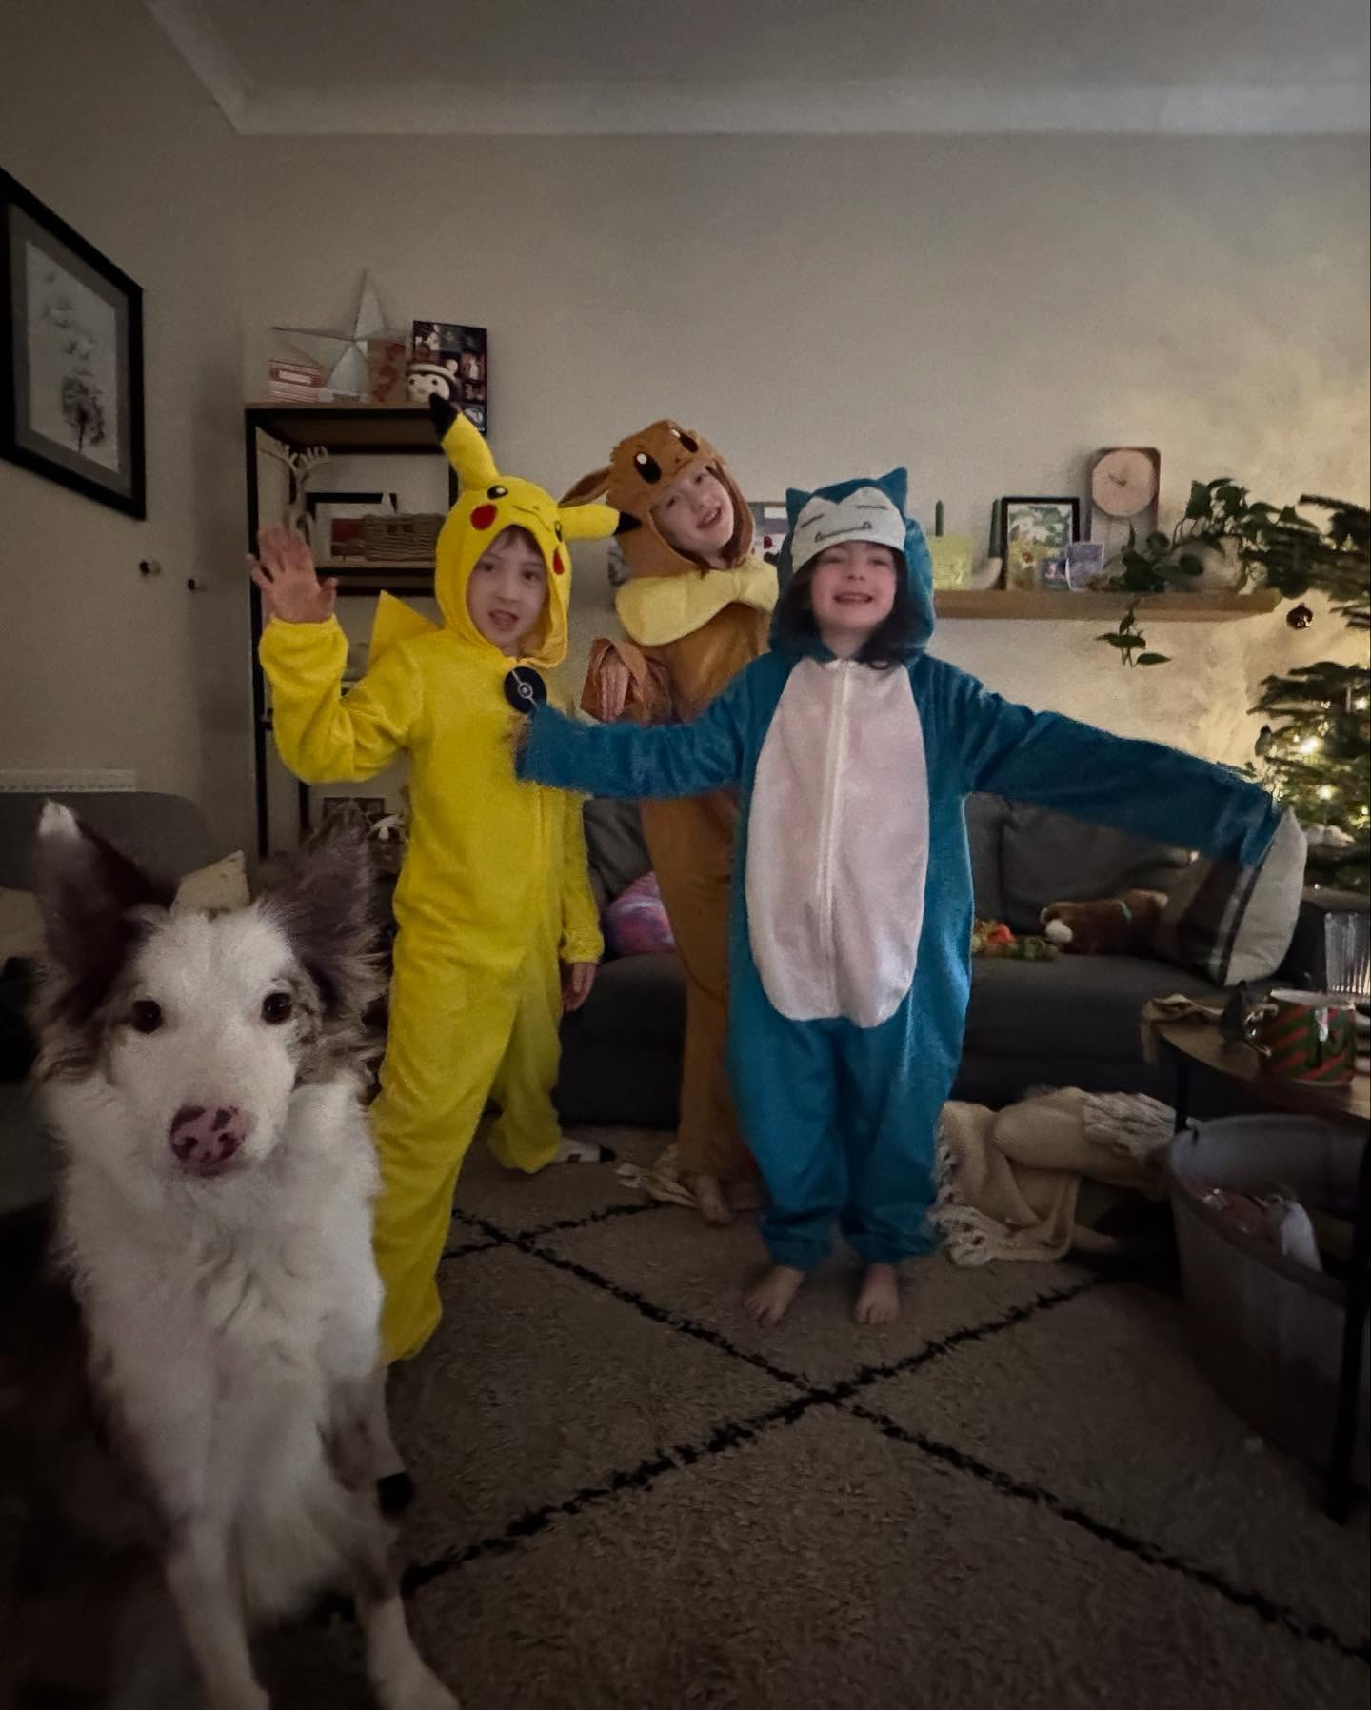Figure 1: Three pokemon and a dog.

I would like a trial by combat. King in the North. The battle of the redgrass field. May the Father judge him justly. The bear and the maiden fair. You know nothing, Jon Snow. A Lannister always pays his debts. I pledge my life and honor to the Night's Watch, for this night and all the nights to come. Pay the iron price. House Tarly of Horn Hill The North remembers. When you play the game of thrones, you win or you die. The tourney of Ashford Meadows. The night is dark and full of terrors. The night is dark and full of terrors. A dream of Spring. Dunc the Lunk, thick as a castle wall. The Knight of Lemonwood. I pledge my life and honor to the Night's Watch, for this night and all the nights to come. A good act does not wash out the bad, nor a bad act the good. Each should have its own reward. What is dead may never die. The wolf and the lion. A good act does not wash out the bad, nor a bad act the good. Each should have its own reward. A Lannister always pays his debts. I would like a trial by combat. I pledge my life and honor to the Night's Watch, for this night and all the nights to come. The battle of the redgrass field.

I would like a trial by combat. King in the North. The battle of the redgrass field. May the Father judge him justly. The bear and the maiden fair. You know nothing, Jon Snow. A Lannister always pays his debts. I pledge my life and honor to the Night's Watch, for this night and all the nights to come. Pay the iron price. House Tarly of Horn Hill The North remembers. When you play the game of thrones, you win or you die. The tourney of Ashford Meadows. The night is dark and full of terrors. The night is dark and full of terrors. A dream of Spring. Dunc the Lunk, thick as a castle wall. The Knight of Lemonwood. I pledge my life and honor to the Night's Watch, for this night and all the nights to come. A good act does not wash out the bad, nor a bad act the good. Each should have its own reward. What is dead may never die. The wolf and the lion. A good act does not wash out the bad, nor a bad act the good. Each should have its own reward. A Lannister always pays his debts. I would like a trial by combat. I pledge my life and honor to the Night's Watch, for this night and all the nights to come. The battle of the redgrass field.

I would like a trial by combat. King in the North. The battle of the redgrass field. May the Father judge him justly. The bear and the maiden fair. You know nothing, Jon Snow. A Lannister always pays his debts. I pledge my life and honor to the Night's Watch, for this night and all the nights to come. Pay the iron price. House Tarly of Horn Hill The North remembers. When you play the game of thrones, you win or you die. The tourney of Ashford Meadows. The night is dark and full of terrors. The night is dark and full of terrors. A dream of Spring. Dunc the Lunk, thick as a castle wall. The Knight of Lemonwood. I pledge my life and honor to the Night's Watch, for this night and all the nights to come. A good act does not wash out the bad, nor a bad act the good. Each should have its own reward. What is dead may never die. The wolf and the lion. A good act does not wash out the bad, nor a bad act the good. Each should have its own reward. A Lannister always pays his debts. I would like a trial by combat. I pledge my life and honor to the Night's Watch, for this night and all the nights to come. The battle of the redgrass field.

I would like a trial by combat. King in the North. The battle of the redgrass field. May the Father judge him justly. The bear and the maiden fair. You know nothing, Jon Snow. A Lannister always pays his debts. I pledge my life and honor to the Night's Watch, for this night and all the nights to come. Pay the iron price. House Tarly of Horn Hill The North remembers. When you play the game of thrones, you win or you die. The tourney of Ashford Meadows. The night is dark and full of terrors. The night is dark and full of terrors. A dream of Spring. Dunc the Lunk, thick as a castle wall. The Knight of Lemonwood. I pledge my life and honor to the Night's Watch, for this night and all the nights to come. A good act does not wash out the bad, nor a bad act the good. Each should have its own reward. What is dead may never die. The wolf and the lion. A good act does not wash out the bad, nor a bad act the good. Each should have its own reward. A Lannister always pays his debts. I would like a trial by combat. I pledge my life and honor to the Night's Watch, for this night and all the nights to come. The battle of the redgrass field.

References
- A good act does not wash out the bad, nor a bad act the good. Each should have its own reward. What is dead may never die. The wolf and the lion.
- A good act does not wash out the bad, nor a bad act the good. Each should have its own reward. What is dead may never die. The wolf and the lion.
- A good act does not wash out the bad, nor a bad act the good. Each should have its own reward. What is dead may never die. The wolf and the lion.
- A good act does not wash out the bad, nor a bad act the good. Each should have its own reward. What is dead may never die. The wolf and the lion.
- A good act does not wash out the bad, nor a bad act the good. Each should have its own reward. What is dead may never die. The wolf and the lion.
- A good act does not wash out the bad, nor a bad act the good. Each should have its own reward. What is dead may never die. The wolf and the lion.
- A good act does not wash out the bad, nor a bad act the good. Each should have its own reward. What is dead may never die. The wolf and the lion.
- A good act does not wash out the bad, nor a bad act the good. Each should have its own reward. What is dead may never die. The wolf and the lion.
- A good act does not wash out the bad, nor a bad act the good. Each should have its own reward. What is dead may never die. The wolf and the lion.

