Acknowledgements
I would like to thank my supervisor Dr. Vladimir Teif for his constant guidance and support throughout this project.
A special thanks to my friends for always keeping me motivated and encouraging me along the way.

Introduction

Rheumatoid Arthritis: Epidemiology, Diagnosis, and Epigenetics
Rheumatoid arthritis (RA) is a chronic, systemic autoimmune disease characterised by joint inflammation causing pain, stiffness, swelling, and potential joint damage (Lee et al., 2017). It often begins in small joints, progressing to larger ones, and can affect extra-articular sites like the skin, eyes, and lungs, leading to deformities, bone erosion, and disability if untreated (Bullock et al., 2018). RA affects 0.24% to 1% of the global population, with higher rates in the U.S., Europe, Australia (2%), and Native American populations (Pima 5.3%, Chippewa 6.8%), while being rarer in Africa and Asia (Venetsanopoulou et al., 2023). Early diagnosis is crucial for effective management, yet RA diagnosis remains challenging due to the lack of highly specific biomarkers.
Studies show that rheumatoid factor (RF) and anti-citrullinated peptide antibodies (ACPA) are key biomarkers for RA (Zhao and Li, 2018), but they are not specific to RA and can occur in other conditions or healthy individuals. Additionally, early RA symptoms often overlap with diseases like osteoarthritis (OA), complicating diagnosis. Recent studies have emphasised the role of epigenetic mechanisms in RA development, which regulate chromatin structure and gene expression without changing the DNA sequence, influencing cellular behaviour and contributing to disease progression (Araki and Mimura, 2016).

Chromatin Structure, Nucleosome Positioning, and their Role in RA
In eukaryotic cells, genetic information is stored and maintained in the form of chromatin, as shown in Figure 1. The fundamental units of chromatin are called nucleosomes; they consist of a histone octamer, which is a protein containing two copies of H2A, H2B, H3, and H4, wrapped around approximately 147 base pairs of DNA (Li, Peng and Panchenko, 2022). These nucleosomes are connected by short DNA segments called linker DNA, forming nucleosomal arrays that interact with neighbouring nucleosomes to form a polymer resembling "beads on a string," which can be termed as the primary structure of the chromatin. Histone N-terminal tails extend from nucleosomes into the nuclear lumen, providing sites for post-translational modifications that regulate chromatin accessibility. Additionally, histone H1 binds linker DNA, stabilising chromatin structure. Upon further condensation, it forms the secondary and tertiary higher-order chromatin structures (Luger, Dechassa and Tremethick 2012). Nucleosome positioning influences whether a region is in an open, transcriptionally active state (euchromatin) or a tightly packed, repressive state (heterochromatin) (Handy, Castro and Loscalzo, 2011). Chromatin remodelling complexes and histone modifications dynamically alter nucleosome arrangement to control DNA accessibility for regulatory proteins and transcription factors. In general, coding regions tend to have dense nucleosome occupancy (condensed chromatin), while regulatory elements such as enhancers, promoters, and terminators are typically nucleosome-depleted, allowing for transcriptional activation (Struhl and Segal, 2013).
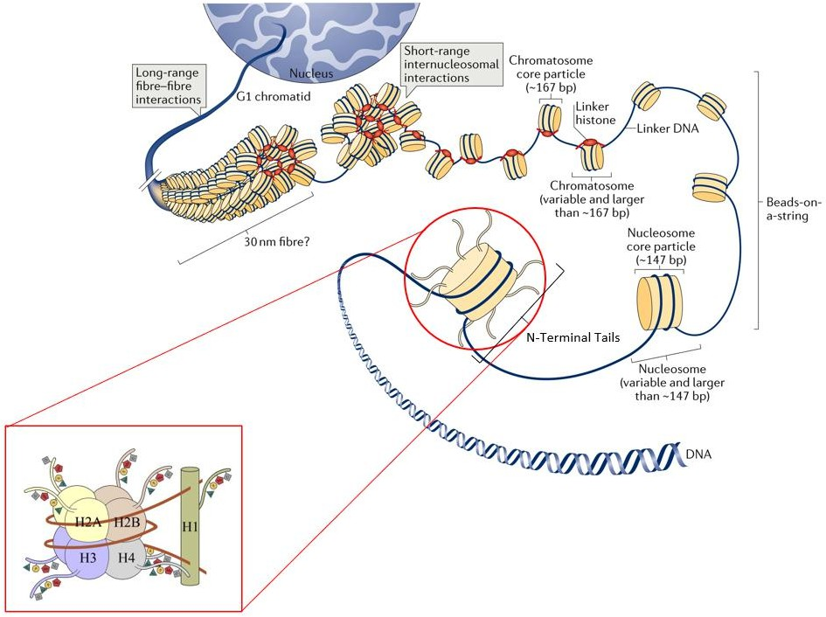
Figure 1. Chromatin Structural Organisation with a Focus on Nucleosome Structure.
This figure provides a labelled schematic of chromatin structure, with a detailed zoom-in on the nucleosome, highlighted in red.
Combined figure adapted from Li, Ding and Zheng (2014) and Fyodorov et al. (2018).

Epigenetic modifications, including DNA methylation and histone modifications, are key regulators of chromatin structure and gene expression. DNA methylation involves the addition of a methyl group to the C5 position of cytosine, forming 5-methylcytosine, which represses gene expression by recruiting silencing proteins or preventing the binding of transcription factors (Moore, Le and Fan, 2013). Post-translational modifications of histones, like methylation, acetylation, phosphorylation, and ubiquitination, regulate chromatin structure and gene expression. Histone methylation provides long-term epigenetic memory, controlling gene activation or silencing, while acetylation loosens chromatin structure to promote transcription (Lui et al., 2023). Ubiquitination targets histones for degradation or modulates transcriptional activity, while phosphorylation allows for rapid chromatin changes in response to cellular signals like DNA damage (Lui et al., 2023). Together, these modifications dynamically influence chromatin organisation, ensuring both stable gene regulation and adaptability to environmental signals.
The positioning of nucleosomes is another important component of gene regulation, as the presence and absence of nucleosomes around promoter regions and transcription start sites blocks the retrieval of the regulatory elements. Several factors influence nucleosome positioning and chromatin structure, as highlighted by Teif and Clarkson (2019). The dyad position, marking the nucleosome centre, determines whether regulatory DNA elements like promoters or enhancers are accessible or occluded. Nucleosome occupancy—the likelihood of a DNA site being bound by a nucleosome—regulates transcription, with high nucleosome occupancy repressing gene expression and low nucleosome occupancy facilitating it. The stability, accessibility, and fuzziness of nucleosomes also affect DNA exposure, impacting transcription factor binding and polymerase activity. The nucleosome repeat length (NRL) further shapes chromatin organisation, as shorter NRLs promote tighter packing, while longer NRLs create a more open and transcriptionally active chromatin state (Kornberg and Lorch, 1999; Struhl and Segal, 2013).
Nucleosomes undergo dynamic changes, including histone eviction, reassembly, and the incorporation of specialised histone variants, which influence gene regulation and DNA repair. Covalent histone modifications further impact chromatin structure, altering histone–DNA interactions and regulatory factor engagement. This interplay shapes a chromatin landscape that can either promote or repress transcription, depending on cellular needs (Bai and Morozov, 2010). Altered nucleosome positioning in monocytes may drive RA-related chromatin dysregulation in peripheral blood, contributing to inflammation and osteoclast differentiation. The extent of this chromatin remodelling correlates with serum C-reactive protein levels, linking nucleosome positioning to RA-associated inflammatory responses (Zong et al., 2021).

ATAC-seq and its Role in Studying Chromatin Accessibility
To study the epigenetic landscape, several high-throughput sequencing technologies have been developed, with Assay for Transposase-Accessible Chromatin sequencing (ATAC-seq) being one of the most efficient methods for identifying chromatin accessibility (Yan et al., 2020). Figure 2 shows the ATAC-seq mechanism and peak calling process. ATAC-seq efficiently maps open chromatin regions where transcription factors bind, enabling the comparison of chromatin accessibility across different conditions (Grandi et al., 2022). This technique uses a hyperactive Tn5 transposase, preloaded with sequencing adapters, which targets accessible chromatin regions. It inserts these adapters into nucleosome-depleted areas while creating 9-bp staggered nicks in the chromatin. These nicks are repaired, resulting in a 9-bp duplication at the insertion sites, which serves as a marker to accurately map open chromatin regions. Following fragmentation, paired-end sequencing is performed, and the raw reads undergo quality control to assess base quality, GC content, and adapter contamination. Overrepresented adapters are trimmed, and the cleaned reads are aligned to a reference genome. Peak calling then identifies accessible chromatin regions, such as promoters and enhancers, which are crucial for understanding gene regulation and chromatin accessibility (Yan et al., 2020). One of the advantages of ATAC-seq is its time-efficient protocol. It requires as few as 500 to 50,000 cells, unlike other techniques like DNase-seq and FAIRE-seq, which need millions of cells. Furthermore, ATAC-seq does not require rigid size selection during library preparation, allowing for the analysis of nucleosome positioning alongside chromatin accessibility (Yan et al., 2020). For instance, a previous ATAC-seq study revealed subtle differences in gene expression regulation specific to each synovial pathotype, highlighting its potential in identifying therapeutic targets for RA (Hughes, 2023). The identification of unique epigenetic patterns in patients with RA can offer insights into disease mechanisms and aid in pinpointing therapeutic targets.

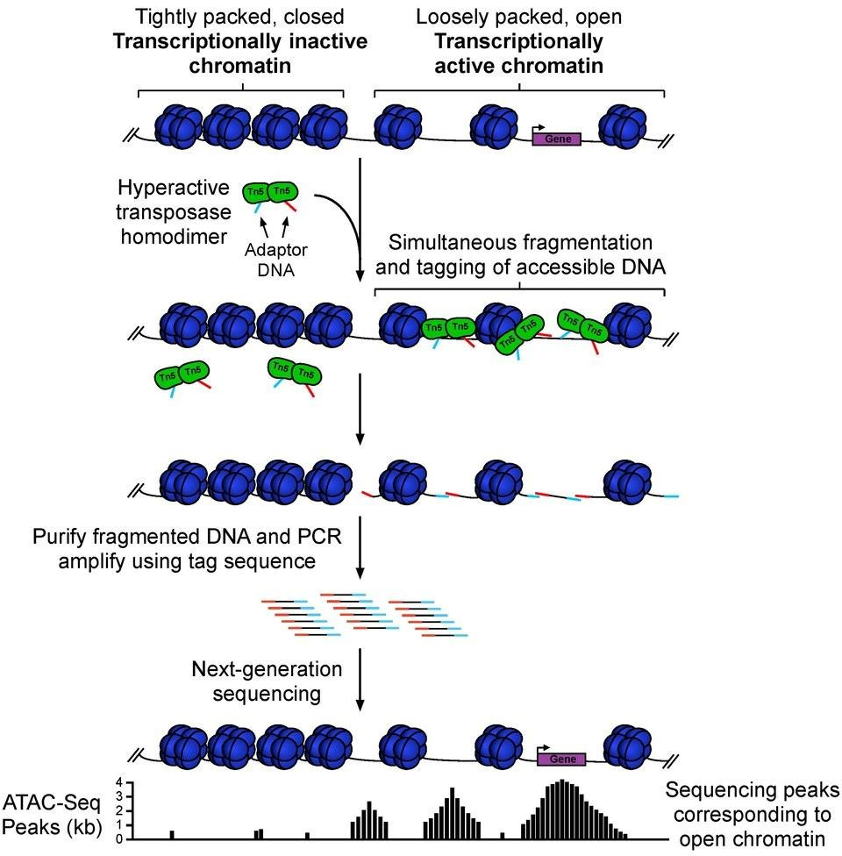
Figure 2. Overview of the Mechanism of Assay for Transposase-Accessible Chromatin Sequencing (ATAC-seq).
Figure 2 is a schematic of the ATAC-seq workflow for identifying chromatin accessibility. The Tn5 transposase (green tags) inserts sequencing adapters (light blue and red) into accessible chromatin regions, marking nucleosome-depleted areas. The blue shapes represent histone octamers. This process enables the mapping of open chromatin regions, which are crucial for understanding gene regulation.
Figure adapted from Davis (no date).

Role of Nucleosome Positioning in RA: Biomarker for Early Diagnosis
Despite extensive research on cell-free DNA (cfDNA), which consists of extracellular fragments of primarily double-stranded nuclear and mitochondrial DNA circulating in body fluids such as blood plasma (Kustanovich et al., 2019), significant gaps remain in understanding its role in disease. cfDNA’s in vivo nucleosome footprint reveals its tissue of origin (Qi et al., 2023); yet, while research has primarily focused on using cfDNA concentration to assess its correlation with disease activity in RA, inconsistent results have suggested that cfDNA alone may not be a reliable biomarker. For instance, Dunaeva et al. (2015) and Jørgensen et al. (2011) reported lower cfDNA levels in the sera of patients with established RA compared to those in healthy samples. In contrast, other studies (Bartoloni et al., 2011; Zhong et al., 2007; Leon et al., 1981) observed increased cfDNA concentrations in patients with RA. These differences may arise from variations in techniques and DNA targets, but they suggest that cfDNA is not a reliable diagnostic biomarker or tool for tracking disease progression (Dunaeva et al., 2015). Nucleosome positioning, which has been linked to various diseases such as cancer, metabolic disorders, autoimmune diseases, and neurodegenerative conditions, is emerging as a promising biomarker (Penny et al., 2024; Fahmueller et al., 2012; Yehya, Thomas and Margulies, 2016). While it has been extensively studied in colorectal, lung, breast, and ovarian cancers (Fahmueller et al., 2012; Jacob et al., 2024; Vanderstichele et al., 2022; Wei et al., 2015), its role in autoimmune diseases like RA remains underexplored.
Evidence suggests that altered chromatin accessibility and nucleosome positioning contribute to RA. In a study by Jadhav et al. (2022), chromatin accessibility in CD4 T cells revealed changes in nucleosome positioning at RA susceptibility loci, suggesting its potential relevance in RA pathogenesis. Since nucleosome positioning influences gene expression and immune regulation, analysing its patterns in RA could serve as a biomarker for early diagnosis and treatment response, improving precision medicine approaches. RA, a complex autoimmune disease with an unclear aetiology, impacts quality of life and can lead to disability. Early diagnosis is essential, but research on nucleosome positioning in RA is limited compared to that on autoimmune diseases like systemic lupus erythematosus and lupus flares (Ghiggeri et al., 2019), highlighting a significant research gap. This study aims to investigate chromatin accessibility by analysing nucleosome positioning in RA using ATAC-seq data from the NCBI GEO Database and bioinformatics tools such as Bowtie, MACS2, BEDTools, OriginPro, the UCSC Genome Browser, and WebGestalt. It focuses on the potential of altered nucleosome positioning in patients with RA as a biomarker for early diagnosis, which could also help track treatment progress and lead to personalised medicine and targeted therapies (Cribbs, Feldmann and Oppermann, 2015).

Methods
Figure 3 shows an outline of the methods used in this study.
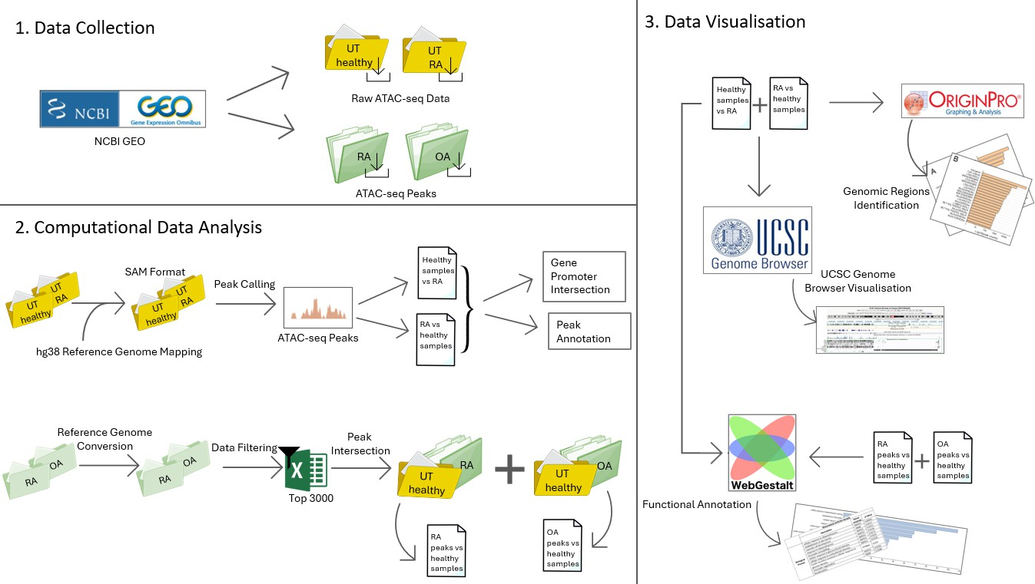
Figure 3. Overview of the Methods for Studying RA and Nucleosome Positioning.
This flow chart shows the steps involved in investigating RA and the role of nucleosome positioning in early diagnosis. It outlines the key stages of data collection, processing using computational analysis, and data visualisation using different bioinformatics tools to analyse chromatin accessibility and nucleosome positioning in healthy samples vs RA.

ATAC-seq Datasets
Two datasets were downloaded from the National Center for Biotechnology Information (NCBI) Gene Expression Omnibus (GEO) (Edgar, Domrachev and Lash, 2002), a publicly accessible repository for functional genomics data, which includes high-throughput gene expression and epigenomic datasets database as detailed below.
The first dataset (GEO accession: GSE148403) used in this study contains ATAC- seq data from Fibroblast-Like Synoviocytes (FLS) isolated from three RA-FLS patients and three healthy donors (Krishna et al., 2021). Only untreated RA and untreated healthy samples were used for this analysis. Experimental data of this dataset was generated according to the protocol described by Buenrostro et al. (2013). ATAC-seq was performed by Epinomics (San Francisco, CA), and the resulting FASTQ files were processed in-house using a custom analysis pipeline. Raw data, provided in the Sequence Read Archive (SRA) format, were used for this analysis.
The second dataset (GEO accession: GSE112658) used in this study included 22 open chromatin datasets, which were profiled by ATAC-seq to identify regions of accessible chromatin (Ai et al., 2018). This dataset is based on synovial tissues obtained from patients with RA and patients with OA during total joint replacement or synovectomy, with diagnoses confirmed based on American College of Rheumatology criteria (Ai et al., 2018). The mean ages of the RA and patients with OA were 55 ± 9 and 66 ± 12 years, respectively, with joint locations including knee, hip, and hand for RA, and knee and hip for OA. ATAC-seq sample preparation followed a previously established protocol (Buenrostro et al., 2013). Raw reads were mapped by the authors to the hg19 genome using Bowtie, followed by the normalisation of read depth. Differentially modified epigenetic regions were identified using the DiffBind package with a q-value threshold of <0.05. Peak calling was performed using MACS2 (version 2.1.0.20150420.1) on the processed data (Ai et al., 2018).

Computational Data Analysis
The datasets obtained from NCBI GEO were analysed using Ceres, the University of Essex's High-Performance Computing Cluster (HPCC). Remote access to the cluster was established through UNIX commands via PuTTY v0.83 (Tatham, 2011), a secure shell and Telnet client, ensuring secure connections to the remote servers for data analysis. PuTTY was used to run files, make directories, and download datasets from GEO. WINSCP v6.3.5 (https://winscp.net/) was used to transfer and organise files.
The raw data from the dataset published by Krishna et al. (2021), in SRA format, was mapped using Bowtie2 v2.5.1 (Langmead and Salzberg, 2012) to the human genome assembly hg38, converting them to SAM format. The SAM files were then used to call peaks using MACS2 v2.2.9.1 (Zhang et al., 2008). Two types of peaks were called: (1) untreated RA vs untreated healthy (referred to as RA vs healthy samples) and (2) untreated healthy vs untreated RA (referred to as healthy samples vs RA).
The resulting NarrowPeak files were intersected with the gene promoters on hg38, where the promoters were defined as the [-1000, 1000] regions around transcription start sites (based on the RefSeq annotation provided by my supervisor) using the command BEDTools v2.29.2 (Quinlan and Hall, 2010). Peak annotation was then performed using HOMER 5.1 (Heinz et al., 2010) with the annotatePeaks.pl script based on the hg38 genome. This generated a text file containing information about nearby genes, genomic features, and other relevant annotations.
For the second dataset published by Ai et al. (2018), ATAC-seq peaks were directly available on GEO and downloaded using the wget command. Since the dataset was mapped to hg19, the peaks were first converted to hg38 using the liftOver tool (Hinrichs et al., 2006) of the UCSC Genome Browser before any further analysis (Kent et al., 2002). Since the peaks were in a non-standard format (merged multiple peaks and reporting genomic windows with peak scores), filtering was applied to select the top 3000 genomic regions with the highest peak scores. The top 3000 peaks from each RA and OA sample were intersected with the untreated healthy dataset, showing peaks present in (i) RA and not in healthy (RA peaks vs healthy samples) and (ii) OA and not in healthy (OA peaks vs healthy samples). These resulting peaks were further intersected with the gene promoters on hg38, defined as the [-1000, 1000] regions around transcription start sites, to connect them to the gene annotations.

Data Visualisation
The files generated from the peak annotation were visualised using OriginPro (https://www.originlab.com/), a software for data analysis, graphing, and visualisation. For each dataset (RA vs healthy samples and healthy sample vs RA), a bar graph was constructed to visualise the regions where the peaks were most enriched. A logarithmic scale was applied to the x-axis to better visualise small changes. The y-axis displayed the genomic regions, with the most enriched regions plotted at the top. The genomic locations of these peaks were further visualised using the UCSC Genome Browser, focusing on the centromeric region of chromosome 1. Custom tracks for the healthy samples vs RA and RA vs healthy samples datasets were added to complement the bar graph visualisations. The files generated from the intersection with promoter regions provided a list of overlapping genes, which were functionally annotated using the WEB-based Gene Set Analysis Toolkit (WebGestalt) (Elizarraras et al., 2024). Gene Ontology labels were assigned, and enriched terms were identified for these genes. For the RA vs healthy samples dataset, no terms were enriched at an FDR <0.05. Therefore, the top 10 terms across three categories—biological processes, cellular components, and molecular functions—were selected. For the healthy samples vs RA dataset, an FDR <0.05 was applied across the same categories. To facilitate visualisation, tables with gene names were created, and bar graphs from WebGestalt were imported as they were. For comparative analysis, functional annotation was also conducted for RA peaks vs healthy samples and OA peaks vs healthy samples. For RA peaks vs healthy samples, the top 10 terms across all categories were used. For OA peaks vs healthy samples, the thresholds were set as follows: FDR <0.05 for biological processes, <0.1 for cellular components, and <0.9 for molecular functions. For all functional annotations, the genome hg38 was selected as the reference set.

Results

Genomic Distribution of ATAC-seq Peaks in RA and Healthy Samples
To understand how chromatin accessibility differs between RA and healthy samples, a comparative analysis was conducted. To investigate these differences, ATAC-seq data from both groups, as reported by Ai et al. (2018) and Krishna et al. (2021), were analysed. The goal was to identify regions with variations in chromatin accessibility between conditions. To do this, two subsets of ATAC-seq peaks were defined: (1) those which are not present in healthy but appear in RA and (2) those which are present in healthy but disappear in RA.
Firstly, the types of genomic regions enriched in each of these two subsets of ATAC-seq peaks were examined. Figure 4 shows the distribution of these two subsets of ATAC-seq peaks across the genome, with RA compared to healthy samples in panel A and healthy samples compared to RA in panel B. The x-axis represents the number of peaks on a log scale, and the y-axis indicates the types of genomic regions where these peaks are found.
In Figure 4A, which details the annotation of peaks unique to RA (not present in healthy), the most enriched peaks were found in repetitive DNA regions, specifically the ALR/Alpha satellite and SST1 satellite regions, followed by intergenic regions. The high peak frequency in intergenic regions suggests these non-coding DNA stretches may influence chromatin remodelling. Simple repeat elements, like (AATGGAATGG)n and (AATGG)n, also showed high peak frequency. These repeats, often found in promoters, untranslated regions, or coding sequences, are prone to mutations that can alter repeat numbers and affect gene function (Fondon et al., 2008), suggesting a potential role in disease progression. Enrichment was also observed in Alu elements, like AluSc8, which can influence gene expression when located near a gene (Deininger, 2011). Alu elements are known to promote stable DNA–histone interactions, which can affect nucleosome positioning, chromatin accessibility, and gene regulation (Englander and Howard, 1995). Peaks were further enriched in CpG islands and genic regions, including exons and introns.
Overall, the enrichment of peaks in satellite regions and simple repeat elements suggests that these regions may contribute to chromatin organisation and genome stability in RA compared to healthy samples. In contrast, ATAC-seq peaks present in healthy samples but not present in RA were mostly enriched in intergenic regions and CpG islands (Figure 4B). The enrichment of intergenic regions suggests that in the absence of disease, chromatin is more accessible in non-coding regions, potentially facilitating regulatory activity under normal physiological conditions. CpG islands, which play a role in DNA methylation and epigenetic regulation, were the second most enriched. Several LINE and SINE elements, including L2, L1, Alu, MIR, and CR1, were also enriched in ATAC-seq peaks that are present in healthy samples but lost in RA. These elements regulate gene expression by modifying chromatin structure.
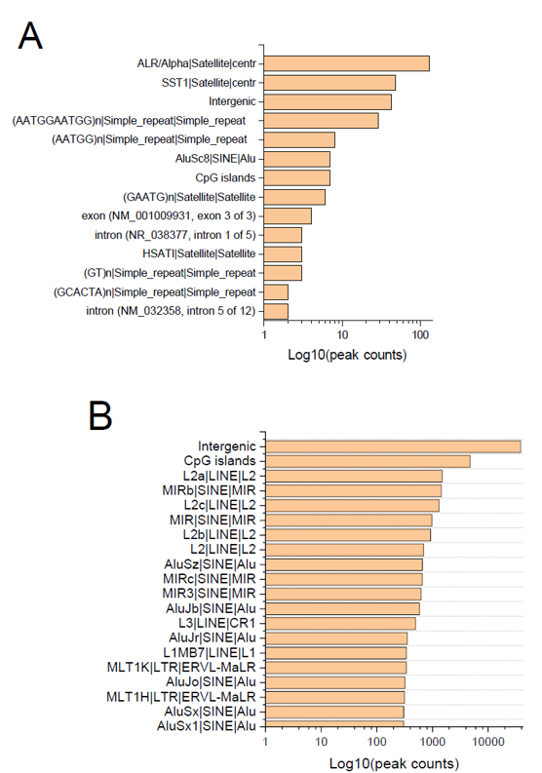
Figure 4. Distribution of ATAC-seq Peaks in RA vs Healthy Samples.
A) ATAC-seq peaks that are present in RA but not in healthy samples. B) ATAC-seq peaks that are present in healthy samples but not in RA. The x-axis represents the log10 (peak counts), while the y-axis lists the type of annotated genomic regions. The regions are ordered by peak frequency, with the most enriched regions at the top. In RA samples, peaks are most enriched in satellite regions, whereas peaks in healthy samples are predominantly in intergenic regions and CpG islands.
To follow up on the finding that most of the peaks unique to RA are enriched in repetitive DNA regions rather than gene bodies, peaks were visualised using the UCSC Genome Browser. Figure 5 shows a screenshot of the UCSC Genome Browser displaying the centromere region on chromosome 1.
In the blue box, the healthy vs RA ATAC-seq peaks are shown. Most of these peaks align with reference sequence genes from NCBI (RefSeq genes), represented by dark blue boxes and connecting lines that indicate exons and introns. In contrast, the yellow box shows the RA vs healthy ATAC-seq peaks, where most of the peaks are located within repeating elements, highlighted in the green box. These elements are predominantly satellite regions, with one peak aligning with a known genetic variant. This pattern reinforces the idea that chromatin remodelling in RA may be driven by structural changes in repeat elements rather than alterations in gene-coding regions.

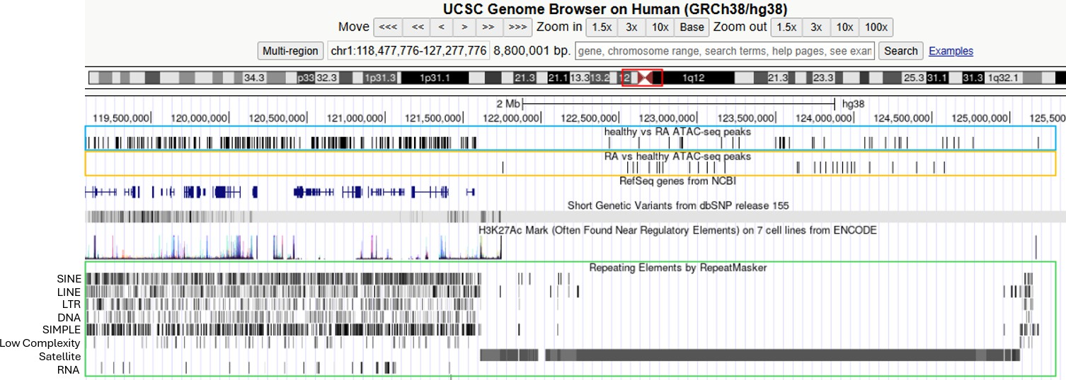
Figure 5. UCSC Genome Browser Visualisation of ATAC-seq Peaks in RA and Healthy Samples.
Screenshot of the UCSC Genome Browser showing the centromeric region on chromosome 1. This figure illustrates the genomic locations of peaks in each sample, highlighting their enrichment in repetitive regions. The blue box highlights ATAC-seq peaks from healthy samples compared to those in RA, while the yellow box shows ATAC-seq peaks from RA compared to those in healthy samples. The green box indicates DNA sequence repeats elements, where most RA-specific peaks are located.

Functional Annotation Analysis of RA, OA, and Healthy Samples
ATAC-seq peaks were mapped to the hg38 reference genome to analyse genes marked by accessible chromatin in RA but absent in healthy samples. Subsets of peaks appearing or disappearing between RA, OA, and healthy conditions were defined, then intersected with annotated gene promoters to identify RA-specific peaks and explore their potential role in disease onset. The results of this analysis are presented in Table 1, which lists nine genes found only in patients with RA, along with their chromosomal locations. Most of these genes are located on the Y chromosome, while the others are distributed across autosomal chromosomes. This suggests that both sex chromosomes and autosomal genes may contribute to the regulation of chromatin accessibility in RA.

Table 1. Genes Whose Promoters are Marked by ATAC-seq Peaks Appearing in RA vs Healthy Samples and their Chromosomal Locations.
Chromosome No. | Gene
chr Y | OFD1P1Y
chr Y | UTY
chr Y | DDX3Y
chr 22 | FAM118A
chr 13 | LOC124903130
chr 7 | PTPRN2
chr 4 | USP17L22
chr 1 | SMYD3
chr 1 | HRNR

To better understand how these genes influence RA progression, functional annotation using WebGestalt was performed to explore the biological processes, molecular functions, and cellular components associated with genes influencing RA progression. Table 2 summarises the most enriched processes, components, and functions for the RA vs healthy samples and healthy vs RA datasets.

Table 2. Summary of Functional Annotation in RA vs Healthy Samples and Healthy Samples vs RA Datasets.
 | RA vs Healthy Samples |  | Healthy Samples vs RA
 | Description | p-value | Description | p-value
Biological  Process | cellular response to dexamethasone | 0.00961 | cellular response  to stress | 1.8179e-  55
Cellular  Component | MLL3/4 complex | 0.00472 |  | 1.30E-79
Cellular  Component |  |  | catalytic complex
Molecular  Function | histone H3K27me2/H3K27me3  demethylase activity | 0.00201 |  | 7.69E-67
Molecular  Function | histone H3K27me2/H3K27me3  demethylase activity |  | RNA binding

The table summarises the most enriched biological processes, cellular components, and molecular functions identified from the functional annotation of genes present in RA but absent in healthy samples and vice versa. The p-values show the statistical significance of the enrichment.
Figure 6 illustrates the biological processes associated with ATAC-seq genes present in promoter regions in RA but absent in healthy samples. The graph reveals that the most enriched biological process is the cellular response to dexamethasone stimulus, with an enrichment ratio of 103.69. Genes in this category are also enriched in pathways related to glucocorticoid (51.85) and corticosteroid stimulus (43.75), myotube cell development (65.11), and skin barrier establishment (84.84). These findings suggest that these pathways may play a role in immune regulation, inflammation, and muscle maintenance, potentially contributing to disease progression in RA.

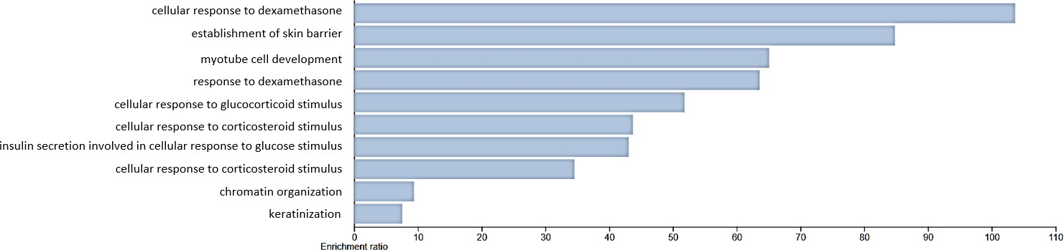
Figure 6. Biological Processes Enriched in Genes Present in RA and Not in Healthy Samples.
The bar chart shows the biological processes associated with genes present in RA but not in healthy samples. Cellular response to dexamethasone has the highest enrichment ratio, followed by establishment of skin barrier. Chromatin remodelling and chromatin organisation has the lowest enrichment ratio.
The genes involved in each of these processes are listed in Table 3, along with their corresponding p-values. As shown in the table, SMYD3 is consistently associated with processes related to steroid response and chromatin regulation, suggesting its potential role in transcriptional regulation in RA.

Table 3. Genes Associated with Enriched Biological Processes in RA Identified from Functional Annotation.
Rheumatoid Arthritis Sample
 | Description | Genes  Involved | p-value
 | cellular response to dexamethasone | SMYD3 | 0.00961
 | establishment of skin barrier | HRNR | 0.0117
 | myotube cell development | SMYD3 | 0.0153
 | response to dexamethasone | SMYD3 | 0.0156
Biological Process | chromatin remodelling | SMYD3 | 0.0171
Biological Process | cellular response to glucocorticoid stimulus | SMYD3 | 0.0191
Biological Process | cellular response to corticosteroid stimulus | SMYD3 | 0.0226
 | insulin secretion involved in cellular response to  glucose stimulus | PTPRN2 | 0.023
 | chromatin organisation | SMYD3 | 0.0258
 | keratinisation | HRNR | 0.0286

The table lists the specific genes involved in the enriched biological processes, along with their p-values identified through a functional annotation analysis of ATAC-seq peaks present in RA and not in healthy samples.
Figure 7 displays the molecular functions of these genes and their enrichment ratios. The most enriched molecular function is histone H3K27me2/H3K27me3 demethylase activity, with an enrichment ratio of 496.03. Methylation of H3K27 is typically associated with gene repression; therefore, demethylation could either activate or repress genes involved in immune function, potentially influencing RA progression (Pan et al., 2018). Other enriched functions include histone modifying activity (23.96) and RNA polymerase II intronic transcription regulatory region sequence-specific DNA binding (310.02). Histone modifications can alter chromatin structure, increasing chromatin accessibility to transcription factors, which could potentially elevate the expression of genes involved in inflammation, contributing to disease progression (Nemtsova et al., 2019). Most of the enriched molecular functions are linked to histone modifications, which may alter chromatin structure and influence the activation and repression of genes impacting RA progression.
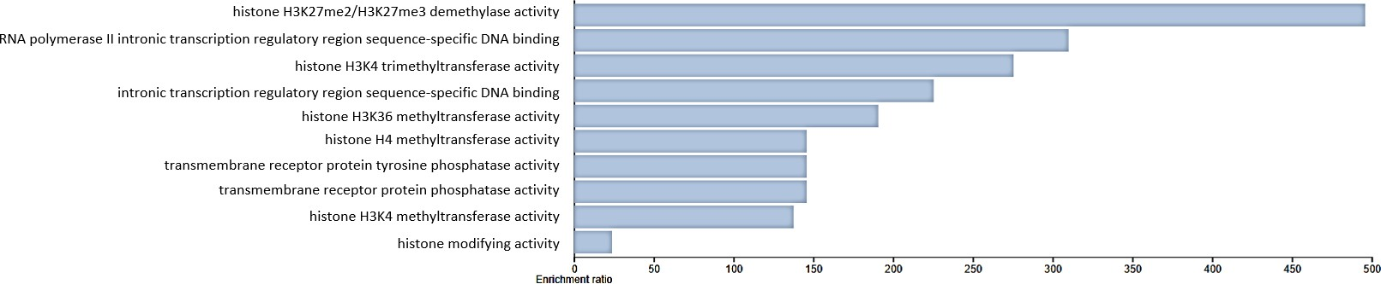
Figure 7. Molecular Functions of Genes Marked by ATAC-seq Peaks Present in RA and Not in Healthy Samples.
The bar chart shows the molecular functions of genes present in RA but not in healthy samples. Histone H3K27me2/H3K27me3 demethylase activity, RNA polymerase II intronic transcription regulatory region sequence- specific DNA binding, and histone H3K4 trimethyltransferase activity are the most enriched functions, whereas histone modifying activity has the lowest enrichment ratio.
Table 4 lists the genes involved in each process, along with their p-values. Most histone modifications are linked to UTY and SMYD3, with PTPRN2 associated with transmembrane receptor protein phosphatase activities. SMYD3 shows higher molecular function activity, and both UTY and SMYD3 are linked to histone-modifying activities, suggesting altered chromatin structure and accessibility that may contribute to RA progression.

Table 4. Genes Associated with Enriched Molecular Functions in RA Identified from Functional Annotation.
Rheumatoid Arthritis Sample
 | Description | Genes  Involved | p-value
 | histone H3K27me2/H3K27me3 demethylase  activity | UTY | 0.00201
 | histone modifying activity | SMYD3  and UTY | 0.00286
 | RNA polymerase II intronic transcription regulatory region sequence-specific DNA  binding | SMYD3 | 0.00322
Molecular Function | histone H3K4 trimethyltransferase activity | SMYD3 | 0.00362
Molecular Function | intronic transcription regulatory region  sequence-specific DNA binding | SMYD3 | 0.00443
 | histone H3K36 methyltransferase activity | SMYD3 | 0.00523
 | histone H4 methyltransferase activity | SMYD3 | 0.00684
 | transmembrane receptor protein tyrosine  phosphatase activity | PTPRN2 | 0.00684
 | transmembrane receptor protein phosphatase  activity | PTPRN2 | 0.00684
 | histone H3K4 methyltransferase activity | SMYD3 | 0.00724

The table lists the specific genes involved in the enriched molecular functions and their p-values identified through a functional annotation analysis of ATAC-seq peaks present in RA and not in healthy samples.
Figure 8 displays the cellular components of these genes and their enrichment ratios. The MLL3/4 complex shows the highest enrichment ratio (211.43), followed by P granules, pole plasm, and germ plasm (97.58), with secretory granules having the lowest ratio (5.69). The MLL3/4 complexes are known to be involved in histone modifications. They are recruited to target enhancers by interacting with sequence-specific transcription factors, including ligand-dependent nuclear receptors and pioneer factors, which initiate the activation of de novo enhancers (Wang et al., 2021). These complexes may activate enhancers that regulate genes involved in immune signalling and inflammation, potentially leading to increased transcription of pro-inflammatory cytokines.
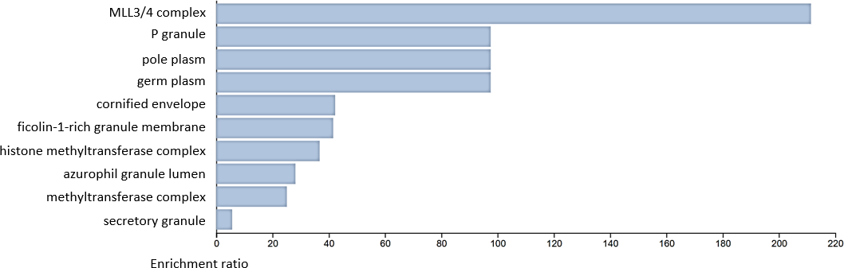
Figure 8. Cellular Components of Genes Marked by ATAC-seq Peaks Present in RA and Not in Healthy Samples.
The bar chart shows the cellular components associated with genes present in RA but not in healthy samples. MLL3/4 complex, P granule, germ plasma, and pole plasma are the most enriched cellular components, whereas secretory granule has the lowest enrichment ratio.

The genes involved in each of these processes are listed in Table 5, along with their p-values indicating the statistical significance of their enrichment. Gene UTY is linked to the MLL3/4 complex, histone methyltransferase membrane, and methyltransferase complex, confirming its role in histone modification and enhancer activation. DDX3Y is associated with P granules, pole plasm, and germ plasm, while HRNR is linked to the cornified envelope, azurophil granule lumen, and secretory granule. PTPRN2 is associated with cellular components such as the ficolin-1-rich granule membrane and secretory granule.

Table 5. Genes Associated with Enriched Cellular Components in RA Identified from Functional Annotation.
Rheumatoid Arthritis Sample
 | Description | Genes  Involved | p-value
 | MLL3/4 complex | UTY | 0.00472
 | P granule | DDX3Y | 0.0102
 | pole plasm | DDX3Y | 0.0102
 | germ plasm | DDX3Y | 0.0102
 | cornified envelope | HRNR | 0.0234
 | ficolin-1-rich granule  membrane | PTPRN2 | 0.0238
Cellular Components | ficolin-1-rich granule  membrane
 | histone methyltransferase  complex | UTY | 0.0269
 | azurophil granule lumen | HRNR | 0.0349
 | methyltransferase complex | UTY | 0.0391
 | secretory granule | HRNR and  PTPRN2 | 0.0446

The table lists the specific genes involved in the enriched cellular functions, along with their p-values, identified through a functional annotation analysis of ATAC-seq peaks present in RA and not in healthy samples.
For the other dataset used for this analysis, genes from ATAC-seq peak mapping were functionally annotated to compare their functions with those observed in RA. Table 6 presents a comparison between the RA peaks vs healthy samples dataset and the OA peaks vs healthy samples dataset. The table outlines the enriched biological processes, molecular functions, and cellular components for both datasets. The RA peaks vs healthy samples dataset was used to support the RA vs healthy samples results, while the OA peaks vs healthy samples dataset was used to compare how the functions of OA differ from those observed in RA.
The biological processes in both RA datasets show some overlap, such as responses to stimuli. The genes in both datasets are involved in responses to various hormones and stimuli. While both datasets also include developmental processes, they differ in biological contexts: the RA peaks vs healthy samples dataset is linked to brainstem development, while the RA vs healthy samples dataset is associated with myotube cell development and skin barrier establishment. Despite these differences, both datasets are involved in processes related to chromatin organisation or modification. For example, chromatin remodelling and chromatin organisation are found in the RA vs healthy samples dataset, while the RA peaks vs healthy samples dataset has an indirect connection to chromatin organisation.
Similarly, overlaps exist in the enriched cellular components and molecular functions. Both datasets are enriched for terms related to vesicle trafficking, exocytosis, and protein secretion. Additionally, histone modification functions in the RA vs healthy samples dataset overlap with Formyl- and Related Transferase Activity, with both datasets involved in enzymatic transfer activities that could potentially impact the methylation and chemical modification of molecules, influencing gene regulation and chromatin remodelling. These overlaps validate the peaks identified in our analysis, demonstrating consistency with a dataset where peaks had been previously identified. The similarities between the results and the established dataset further support the reliability of the peak calling process.
Table 6 further displays the enriched biological processes, cellular components, and molecular functions for the OA peaks vs healthy samples, highlighting the differences in the processes involved in OA compared to those in RA. For instance, OA is associated with negative regulation of apoptosis, suggesting protective mechanisms in joint tissue, whereas RA exhibits increased apoptosis due to autoimmune inflammation (Xu et al., 2015). Another key difference is that OA is more related to structural and extracellular matrix processes, such as the smooth endoplasmic reticulum and cytoplasmic vesicle lumen. In contrast, RA involves more pronounced immune cell activation, cytokine secretion, and synovial inflammation, indicating a stronger focus on immune responses and synovial cell granules in RA. The major distinction between the OA and RA datasets is that OA primarily involves the structural degradation of cartilage, without the autoimmune-driven destruction that characterises RA.
Table 6. Comparative Analysis of the Enriched Biological Processes, Cellular Components, and Molecular Functions Between RA and OA Peaks vs Healthy Samples.

RA Peaks vs Healthy Samples OA Peaks vs Healthy Samples

 | Description | p-value |  | Description |  | p-value
 | tetrahydrofolate |  |  | negative regulation of
 | biosynthetic process | 0.002 |  | apoptotic process |  | 2.20E-06
 | response to | 0.00208
 | corticotropin-releasing
 | hormone
 | cellular response to | 0.00208 |  | negative regulation of |  | 2.74E-06
 | corticotropin-releasing |  |  | programmed cell
 | hormone stimulus |  |  | death
 | de novo IMP | 0.0025
 | biosynthetic process
Biological | XMP metabolic process | 0.00291 |  | negative regulation of |  | 4.40E-06
Process | XMP biosynthetic  process | 0.00291 |  | extrinsic apoptotic  signalling pathway via
 | de novo XMP | 0.00291 death domain
 | biosynthetic process |  |  | receptors
 | folic acid-containing | 0.00291 |  | regulation of extrinsic |  | 0.0000181
 | compound biosynthetic |  |  | apoptotic signalling
 | process |  |  | pathway via death
 | de novo AMP | 0.00333 |  | domain receptors
 | biosynthetic process
 | brainstem development | 0.00333
 | Cul2-RING ubiquitin | 0.0112 |  | platelet alpha granule |  | 0.000119
Cellular | ligase complex
Component | receptor complex | 0.0133 |  | secretory granule |  | 0.000242
 | microvillus membrane | 0.0148 |  | cytosolic ribosome |  | 0.000251
 | brush border membrane | 0.0267 |  |  |  | 0.000324
 | clathrin-coated pit |  | 0.0342 | secretory granule  lumen
 | microvillus |  | 0.0429 | cytoplasmic vesicle lumen | 0.000335
 | brush border |  | 0.0468 | cytoplasmic vesicle lumen
 | axon terminus |  | 0.0498 | vesicle lumen | 0.000339
 | neuron projection  terminus |  | 0.0567 | smooth endoplasmic  reticulum | 0.000433
 | cluster of actin-based  cell projections |  | 0.0711 | secretory vesicle | 0.000635
 | cyclohydrolase activity |  | 0.00231 | structural molecule activity | 0.00103
 | LBD domain binding |  | 0.00322 | structural molecule activity
 | hydroxymethyl-, formyl-  and related transferase activity |  | 0.00368 | peptidase regulator activity | 0.00172
 | zinc ion binding |  | 0.00504
 | oestrogen response  element binding |  | 0.00506 | enzyme regulator  activity | 0.00181
Molecular  Function | cadherin binding |  | 0.00913
 | transition metal ion  binding |  | 0.0111 | protein serine/threonine kinase activator activity | 0.00199
 | TBP-class protein  binding |  | 0.0115 | protein serine/threonine kinase activator activity
 | nuclear steroid receptor  activity |  | 0.0115 | glycosaminoglycan  binding | 0.00209
 | metallocarboxypeptidase  activity |  | 0.0137

This table presents the significant biological processes, cellular components, and molecular functions identified in the ATAC-seq peak calling comparing RA peaks vs healthy samples and OA peaks vs healthy samples. The p-value shows the statistical significance of the comparisons.

Discussion
This study investigated whether nucleosome positioning can serve as a biomarker for the early diagnosis of RA, which is crucial as it can alter the disease course, prevent joint erosion, and slow the progression of erosive disease. It can also improve overall disease outcomes, potentially leading to remission (Heidari, 2011). Timely diagnosis helps prevent irreversible joint damage, which typically occurs within the first two years of onset when the rate of erosive joint disease is highest (Visser, 2005). However, many cases of early arthritis are self-limiting, making it difficult to distinguish RA from other types of arthritis. Early differentiation is important to avoid the unnecessary use of disease-modifying antirheumatic drugs, thereby reducing the risk of harm from inappropriate treatment (Visser, 2005; Heidari, 2011).
Nucleosome positioning plays a critical role in regulating gene expression by influencing chromatin accessibility. Altered nucleosome positioning can disrupt gene expression, potentially driving disease onset and progression. Changes in nucleosome positioning, such as nucleosome sliding, can lead to the activation of disease-causing genes, contributing to the development of disease (Jiang and Pugh, 2009). This study therefore investigated nucleosome positioning as a potential biomarker for the early diagnosis of RA. Two ATAC-seq datasets were used: the first focused on FLS from three patients with RA and three healthy donors (Krishna et al., 2021), and the second contained ATAC-seq data from 22 patients with RA and OA (Ai et al., 2018).
ATAC-seq data were used in this analysis, as ATAC-seq identifies open chromatin regions associated with active transcription and regulatory activity. This technique efficiently maps both chromatin accessibility and nucleosome positioning, making it a powerful tool for studying epigenetic regulation (Yan et al., 2020). Additionally, ATAC-seq requires a low number of cells and can provide insights into chromatin structure and gene regulation. These advantages make it ideal for investigating chromatin changes that may influence gene expression.
The tetrahydrofolate biosynthetic process is indirectly linked to chromatin structure through its role in one-carbon metabolism and histone methylation. It contributes to the synthesis of S-adenosylmethionine, a key methyl donor for histone methylation, influencing gene expression and chromatin structure (Serefidou, Venkatasubramani and Imhof, 2019).

Nucleosome Positioning and Chromatin Accessibility in RA
The analysis revealed a significant difference in the number of peaks between RA vs healthy samples and healthy samples vs RA. Specifically, the RA vs healthy samples dataset had a lower number of peaks (n=335) compared to the healthy samples vs RA dataset (n=157184), indicating potential differences in chromatin accessibility. A significant reduction in peaks was observed in intergenic regions and CpG islands, while satellite regions showed an increased enrichment of ATAC-seq peaks. These findings suggest that nucleosome positioning is altered in RA, with reduced accessibility in gene-regulatory regions (CpG islands and intergenic regions) and an increased number of peaks in satellite repeat regions, which may reflect chromatin remodelling associated with disease progression. Additionally, a functional analysis of genes overlapping with the peaks revealed that most were associated with histone modifications, highlighting epigenetic regulation in RA. A consistent involvement of the SMYD3 gene was observed, suggesting a potential role in RA-associated chromatin alterations. SMYD3 is known for its histone methyltransferase activity (Yang et al., 2021). Its persistent presence in the dataset may indicate a link between histone modifications and nucleosome positioning in RA.
The functional annotation revealed a significant enrichment of histone H3K27me2/H3K27me3 demethylation activity within genes enriched in RA but not in healthy samples. This suggests that DNA demethylation may occur in RA, potentially altering gene expression. One possible explanation for this hypomethylation is the absence of DNMT1 in RA samples, as indicated by the lack of DNMT1 peaks in the RA vs healthy samples dataset, whereas DNMT1 peaks were present in the healthy vs RA dataset. This aligns with previous studies that suggest the absence of DNMT1 is associated with DNA hypomethylation in RA (Turek-Plewa and Jagodzinski, 2005; Szyf, 2001; Wilson, Power and Molloy, 2007). Additionally, another study confirmed that RA is characterised by DNA hypomethylation and decreased DNMT1 levels (Payet et al., 2021). Interestingly, even though DNMT3A and DNMT3B peaks were observed in the healthy samples, they were absent in the RA samples. These enzymes are responsible for de novo methylation during primary development (Gujar, Weisenberger and Liang, 2019). The absence of DNMT1, DNMT3A, and DNMT3B peaks is shown in Figure 9. This further supports the idea that the absence of DNA methylation genes may contribute to the epigenetic alterations observed in RA, providing more evidence for the potential role of DNA methylation changes in disease progression.
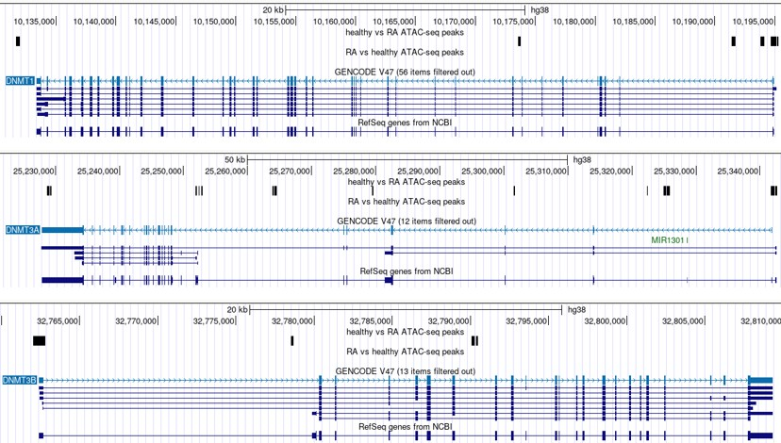
Figure 9. Snapshot of the UCSC Genome Browser Showing the Absence of DNMT1, DNMT3A, and DNMT3B Peaks in RA Compared to Healthy Samples.
This figure displays ATAC-seq peaks from the UCSC Genome Browser, comparing RA and healthy samples. It highlights the differences in peaks present for the DNMT1, DNMT3A, and DNMT3B genes, showing the absence of peaks in RA compared to those in healthy samples.
Furthermore, the results show an enrichment of methyltransferase activity in RA samples, suggesting that the methylation of specific genes may occur in RA but not in healthy individuals. A study by Nakano, Boyle and Firestein (2013) demonstrated that DNA methylation plays a key role in repressing regulatory genes by methylating cytosines in CpG islands; this supports our findings, as reduced peaks were observed at CpG sites in the RA vs healthy samples dataset. Nakano, Boyle and Firestein (2013) also showed that the expression of DNMT genes is suppressed by proinflammatory cytokines such as IL-1β, TNF, and the TLR4 ligand LPS. Since DNMTs are responsible for methylating CpG sites, the suppression of DNMT function may lead to reduced methylation at CpG sites, which is consistent with the hypomethylation observed in our RA samples. While CpG islands exhibit fewer enriched peaks compared to other genomic regions such as satellite regions, intergenic regions, and simple repeats, they remain statistically significant. This reduction in methylation could be attributed to the decreased levels of DNMTs in RA, contributing to the altered DNA methylation landscape observed in our study.

Nucleosome Positioning and Hypomethylation in Repetitive Regions
The enrichment of ALR/Alpha satellite and SST1 satellite regions in RA compared to healthy samples suggests that these regions may be more accessible in RA due to hypomethylation. In healthy samples, these regions are typically silenced by methylation to maintain genome integrity (Papin et al., 2017). However, in RA, hypomethylation could lead to their activation, resulting in chromatin instability. Retrotransposons, which play a critical role in maintaining chromatin structure, are also influenced by methylation status, as their hypomethylation can disrupt chromatin organisation (Liu and Leung, 2025).
The findings demonstrate clear alterations in chromatin structure in RA compared to those in healthy samples, suggesting that in the presence of disease, CpG sites and genic regions become less accessible, leading to dysregulated gene expression. The enrichment of ATAC-seq peaks in repetitive regions indicates a more open chromatin state in these areas, likely due to nucleosome repositioning and hypomethylation, facilitating their activation. Conversely, the loss of peaks in intergenic regions and CpG islands suggests a shift toward a more closed chromatin conformation, restricting access to regulatory elements and contributing to altered gene regulation. One interesting finding in the results is the presence of three Y-linked genes, specifically UTY, which is associated with histone demethylase activity. This is notable since RA is more common in women, partly due to the role of oestrogen in immune regulation (Gerosa et al., 2008). Gaining a deeper understanding of the dataset, including factors such as sample composition and sequencing biases, could help clarify the significance of this observation.

Future Directions for Establishing Nucleosome Positioning as a Biomarker for RA
Nucleosome positioning plays a crucial role in shaping chromatin accessibility, making it a key factor in understanding chromatin changes. This highlights its potential as a biomarker for the early diagnosis of RA. Inflammatory cytokines in RA can alter chromatin structure and accessibility, potentially driving disease progression (Kondo, Kuroda and Kobayashi, 2021). Investigating the interplay between nucleosome positioning and inflammatory pathways may uncover new therapeutic targets. Further exploration through gene expression analysis may provide valuable insights into the molecular mechanisms driving RA onset, potentially aiding in the development of targeted therapies. To build on this study, incorporating more diverse datasets would be beneficial. The dataset used herein focuses on individuals with already-developed RA, which provides valuable insights but does not capture nucleosome positioning changes at different disease stages. Analysing datasets from various RA stages and performing comparative analyses may reveal how nucleosome positioning evolves over time. Furthermore, ensuring a larger sample size, high-quality data, and standardised ATAC-seq methodologies would strengthen the reliability and reproducibility of the findings. Nevertheless, this study confirms that nucleosome positioning changes in fully developed RA, opening the door for future research into its potential as a biomarker for early disease onset.

References
Ai, R., Laragione, T., Hammaker, D., Boyle, D.L., Wildberg, A., Maeshima, K., Palescandolo, E., Krishna, V., Pocalyko, D., Whitaker, J.W., Bai, Y., Nagpal, S., Bachman, K.E., Ainsworth, R.I., Wang, M., Ding, B., Gulko, P.S., Wang, W. and Firestein, G.S. (2018) ‘Comprehensive epigenetic landscape of rheumatoid arthritis fibroblast-like synoviocytes’, Nature Communications, 9(1), article 1921. Available at: https://doi.org/10.1038/s41467-018-04310-9
Araki, Y. and Mimura, T. (2016) ‘The mechanisms underlying chronic inflammation in rheumatoid arthritis from the perspective of the epigenetic landscape’, Journal of Immunology Research, 2016(1), article 6290682. Available at: https://doi.org/10.1155/2016/6290682
Bai, L. and Morozov, A.V. (2010) ‘Gene regulation by nucleosome positioning’, Trends in Genetics, 26(11), pp. 476-483. Available at: https://doi.org/10.1016/j.tig.2010.08.003
Bartoloni, E., Ludovini, V., Alunno, A., Pistola, L., Bistoni, O., Crinò, L. and Gerli, R. (2011) ‘Increased levels of circulating DNA in patients with systemic autoimmune diseases: a possible marker of disease activity in Sjögren’s syndrome’, Lupus, 20(9), pp. 928-935. Available at: https://doi.org/10.1177/0961203311399606
Buenrostro, J.D., Giresi, P.G., Zaba, L.C., Chang, H.Y. and Greenleaf, W.J. (2013) ‘Transposition of native chromatin for fast and sensitive epigenomic profiling of open chromatin, DNA-binding proteins and nucleosome position’, Nature Methods, 10(12), pp. 1213-1218. Available at: https://doi.org/10.1038/nmeth.2688
Bullock, J., Rizvi, S.A.A., Saleh, A.M., Ahmed, S.S., Do, D.P., Ansari, R.A. and Ahmed, J. (2018) ‘Rheumatoid arthritis: a brief overview of the treatment’, Medical Principles and Practice, 27(6), pp. 501-507. Available at: https://doi.org/10.1159/000493390
Cribbs, A., Feldmann, M. and Oppermann, U. (2015) ‘Towards an understanding of the role of DNA methylation in rheumatoid arthritis: therapeutic and diagnostic implications’, Therapeutic Advances in Musculoskeletal Disease, 7(5), pp. 206-219. Available at: https://doi.org/10.1177/1759720X15598307
Davis, S. (no date) ATAC-Seq with Bioconductor. Available at: https://seandavi.github.io/AtacSeqWorkshop/articles/Workflow.html#overview (Accessed: 10/12/2025).
Deininger, P. (2011) ‘Alu elements: know the SINEs’, Genome Biology, 12, article 236. Available at: https://doi.org/10.1186/gb-2011-12-12-236
Dunaeva, M., Buddingh’, B.C., Toes, R.E.M., Luime, J.J., Lubberts, E. and Pruijn, G.J.M. (2015) ‘Decreased serum cell-free DNA levels in rheumatoid arthritis’, Autoimmunity Highlights, 6, pp. 23-30. Available at: https://doi.org/10.1007/s13317-015-0066-6
Edgar, R., Domrachev, M. and Lash, A.E. (2002) ‘Gene Expression Omnibus: NCBI gene expression and hybridization array data repository’, Nucleic Acids Research, 30(1), pp. 207-210. Available at: https://doi.org/10.1093/nar/30.1.207
Elizarraras, J.M., Liao, Y., Shi, Z., Zhu, Q., Pico, A.R. and Zhang, B. (2024) ‘WebGestalt 2024: faster gene set analysis and new support for metabolomics and multi-omics’, Nucleic Acids Research, 52(W1), pp. W415-W421. Available at: https://doi.org/10.1093/nar/gkae456
Englander, E.W. and Howard, B.H. (1995) ‘Nucleosome Positioning by Human Alu Elements in Chromatin (∗)’, Journal of Biological Chemistry, 270(17), pp. 10091-10096. Available at: https://doi.org/10.1074/jbc.270.17.10091
Fahmueller, Y.N., Nagel, D., Hoffmann, R.T., Tatsch, K., Jakobs, T., Stieber, P. and Holdenrieder, S. (2012) ‘Predictive and prognostic value of circulating nucleosomes and serum biomarkers in patients with metastasized colorectal cancer undergoing Selective Internal Radiation Therapy’, BMC Cancer, 12, article 5. Available at: https://doi.org/10.1186/1471-2407-12-5
Fondon, J.W., Hammock, E.A.D., Hannan, A.J. and King, D.G. (2008) ‘Simple sequence repeats: genetic modulators of brain function and behavior’, Trends in Neurosciences, 31(7), pp. 328-334. Available at: https://doi.org/10.1016/j.tins.2008.03.006
Fyodorov, D.V., Zhou, B.R., Skoultchi, A.I. and Bai, Y. (2018) ‘Emerging roles of linker histones in regulating chromatin structure and function’, Nature Reviews. Molecular Cell Biology, 19(3), pp. 192-206. Available at: https://doi.org/10.1038/nrm.2017.94
Gerosa, M., De Angelis, V., Riboldi, P. and Meroni, P.L. (2008) ‘Rheumatoid arthritis: a female challenge’, Women’s Health, 4(2), pp. 195-201. Available at: https://doi.org/10.2217/17455057.4.2.195
Ghiggeri, G.M., D’Alessandro, M., Bartolomeo, D., Degl’Innocenti, M.L., Magnasco, A., Lugani, F., Prunotto, M. and Bruschi, M. (2019) ‘An update on antibodies to nucleosome components as biomarkers of systemic lupus erythematosus and of lupus flares’, International Journal of Molecular Sciences, 20(22), article 5799. Available at: https://doi.org/10.3390/ijms20225799
Grandi, F.C., Modi, H., Kampman, L. and Corces, M.R. (2022) ‘Chromatin accessibility profiling by ATAC-seq’, Nature Protocols, 17(6), pp. 1518-1552. Available at: https://doi.org/10.1038/s41596-022-00692-9
Gujar, H., Weisenberger, D.J. and Liang, G. (2019) ‘The roles of human DNA methyltransferases and their isoforms in shaping the epigenome’, Genes, 10(2), article 172. Available at: https://doi.org/10.3390/genes10020172
Handy, D.E., Castro, R. and Loscalzo, J. (2011) ‘Epigenetic modifications: basic mechanisms and role in cardiovascular disease’, Circulation, 123(19), pp. 2145-2156. Available at: https://doi.org/10.1161/CIRCULATIONAHA.110.956839
Heidari, B. (2011) ‘Rheumatoid Arthritis: Early diagnosis and treatment outcomes’, Caspian Journal of Internal Medicine, 2(1), pp. 161-170.
Heinz, S., Benner, C., Spann, N., Bertolino, E., Lin, Y.C., Laslo, P., Cheng, J.X., Murre, C., Singh, H. and Glass, C.K. (2010) ‘Simple combinations of lineage-determining transcription factors prime cis-regulatory elements required for macrophage and B cell identities’, Molecular Cell, 38(4), pp. 576-589. Available at: https://doi.org/10.1016/j.molcel.2010.05.004
Hinrichs, A.S., Karolchik, D., Baertsch, R., Barber, G.P., Bejerano, G., Clawson, H., Diekhans, M., Furey, T.S., Harte, R.A., Hsu, F. and Hillman-Jackson, J. (2006) ‘The UCSC genome browser database: update 2006’, Nucleic Acids Research, 34(suppl_1), pp. D590-D598. Available at: https://doi.org/10.1093/nar/gkj144
Hughes, S. (2023) Surveying the epigenetic landscape of murine synovitis to explore the heterogeneity of rheumatoid arthritis. PhD Thesis. Cardiff University and Monash University.
Jacob, D.R., Guiblet, W.M., Mamayusupova, H., Shtumpf, M., Ciuta, I., Ruje, L., Gretton, S., Bikova, M., Correa, C., Dellow, E. and Agrawal, S.P. (2024) ‘Nucleosome reorganisation in breast cancer tissues’, Clinical Epigenetics, 16, article 50. Available at: https://doi.org/10.1186/s13148-024-01656-4
Jadhav, R.R., Hu, B., Ye, Z., Sheth, K., Li, X., Greenleaf, W.J., Weyand, C.M. and Goronzy, J.J. (2022) ‘Reduced chromatin accessibility to CD4 T cell super-enhancers encompassing susceptibility loci of rheumatoid arthritis’, EBioMedicine, 76, article 103825. Available at: https://doi.org/10.1016/j.ebiom.2022.103825
Jiang, C. and Pugh, B.F. (2009) ‘Nucleosome positioning and gene regulation: advances through genomics’, Nature Reviews Genetics, 10(3), pp. 161-172. Available at: https://doi.org/10.1038/nrg2522
Jørgensen, M.H., Rekvig, O.P., Jacobsen, R.S., Jacobsen, S. and Fenton, K.A. (2011) ‘Circulating levels of chromatin fragments are inversely correlated with anti-dsDNA antibody levels in human and murine systemic lupus erythematosus’, Immunology Letters, 138(2), pp. 179-186. Available at: https://doi.org/10.1016/j.imlet.2011.04.006
Kent, W.J., Sugnet, C.W., Furey, T.S., Roskin, K.M., Pringle, T.H., Zahler, A.M. and Haussler, D. (2002) ‘The human genome browser at UCSC’, Genome Research, 12(6), pp. 996-1006. Available at: https://doi.org/10.1101/gr.229102
Kondo, N., Kuroda, T. and Kobayashi, D. (2021) ‘Cytokine networks in the pathogenesis of rheumatoid arthritis’, International Journal of Molecular Sciences, 22(20), article 10922. Available at: https://doi.org/10.3390/ijms222010922
Kornberg, R.D. and Lorch, Y. (1999) ‘Twenty-five years of the nucleosome, fundamental particle of the eukaryote chromosome’, Cell, 98(3), pp. 285-294. Available at: https://doi.org/10.1016/S0092-8674(00)81958-3
Krishna, V., Yin, X., Song, Q., Walsh, A., Pocalyko, D., Bachman, K., Anderson, I., Madakamutil, L. and Nagpal, S. (2021) ‘Integration of the transcriptome and genome-wide landscape of BRD2 and BRD4 binding motifs identifies key superenhancer genes and reveals the mechanism of bet inhibitor action in rheumatoid arthritis synovial fibroblasts’, The Journal of Immunology, 206(2), pp. 422-431. Available at: https://doi.org/10.4049/jimmunol.2000286
Kustanovich, A., Schwartz, R., Peretz, T. and Grinshpun, A. (2019) ‘Life and death of circulating cell-free DNA’, Cancer Biology & Therapy, 20(8), pp. 1057-1067. Available at: https://doi.org/10.1080/15384047.2019.1598759
Langmead, B. and Salzberg, S.L. (2012) ‘Fast gapped-read alignment with Bowtie 2’, Nature Methods, 9(4), pp. 357-359. Available at: https://doi.org/10.1038/nmeth.1923
Lee, J.E., Kim, I.J., Cho, M.S. and Lee, J. (2017) ‘A case of rheumatoid vasculitis involving hepatic artery in early rheumatoid arthritis’, Journal of Korean Medical Science, 32(7), pp. 1207-1210. Available at: https://doi.org/10.3346/jkms.2017.32.7.1207
Leon, S.A., Revach, M., Ehrlich, G.E., Adler, R., Petersen, V. and Shapiro, B. (1981) ‘Dna in synovial fluid and the circulation of patients with arthritis’, Arthritis & Rheumatology, 24(9), pp. 1142-1150. Available at: https://doi.org/10.1002/art.1780240905
Li, J., Ding, Y. and Zheng, L. (2014) ‘Histone-mediated transgenerational epigenetics’, in T. Tollefsbol (ed), Transgenerational Epigenetics. Academic Press, pp. 87-103.
Li, S., Peng, Y. and Panchenko, A.R. (2022) ‘DNA methylation: Precise modulation of chromatin structure and dynamics’, Current Opinion in Structural Biology, 75, article 102430. Available at: https://doi.org/10.1016/j.sbi.2022.102430
Liu, K.Y. and Leung, D. (2025) ‘Epigenetic dysregulation of retrotransposons in cancer’, Molecular Cancer Research, 23(5), pp. 369-378. Available at: https://doi.org/10.1158/1541-7786.MCR-24-0744
Liu, R., Wu, J., Guo, H., Yao, W., Li, S., Lu, Y., Jia, Y., Liang, X., Tang, J. and Zhang, H. (2023) ‘Post‐translational modifications of histones: Mechanisms, biological functions, and therapeutic targets’, MedComm, 4(3), e292. Available at: https://doi.org/10.1002/mco2.292
Luger, K., Dechassa, M.L. and Tremethick, D.J. (2012) ‘New insights into nucleosome and chromatin structure: an ordered state or a disordered affair?’, Nature Reviews Molecular Cell Biology, 13(7), pp. 436-447. Available at: https://doi.org/10.1038/nrm3382
Moore, L.D., Le, T. and Fan, G. (2013) ‘DNA methylation and its basic function’, Neuropsychopharmacology, 38(1), pp. 23-38. Available at: https://doi.org/10.1038/npp.2012.112
Nakano, K., Boyle, D.L. and Firestein, G.S. (2013) ‘Regulation of DNA methylation in rheumatoid arthritis synoviocytes’, The Journal of Immunology, 190(3), pp. 1297-1303. Available at: https://doi.org/10.4049/jimmunol.1202572
Nemtsova, M.V., Zaletaev, D.V., Bure, I.V., Mikhaylenko, D.S., Kuznetsova, E.B., Alekseeva, E.A., Beloukhova, M.I., Deviatkin, A.A., Lukashev, A.N. and Zamyatnin Jr., A.A. (2019) ‘Epigenetic changes in the pathogenesis of rheumatoid arthritis’, Frontiers in Genetics, 10, article 570. Available at: https://doi.org/10.3389/fgene.2019.00570
Pan, M.R., Hsu, M.C., Chen, L.T. and Hung, W.C. (2018) ‘Orchestration of H3K27 methylation: mechanisms and therapeutic implication’, Cellular and Molecular Life Sciences, 75, pp. 209- 223. Available at: https://doi.org/10.1007/s00018-017-2596-8
Papin, C., Ibrahim, A., Le Gras, S., Velt, A., Stoll, I., Jost, B., Menoni, H., Bronner, C., Dimitrov, S. and Hamiche, A. (2017) ‘Combinatorial DNA methylation codes at repetitive elements’, Genome Research, 27(6), pp. 934-946. Available at: https://doi.org/10.1101/gr.213983.116
Payet, M., Dargai, F., Gasque, P. and Guillot, X. (2021) ‘Epigenetic regulation (including micro- RNAs, DNA methylation and histone modifications) of rheumatoid arthritis: a systematic review’, International Journal of Molecular Sciences, 22(22), article 12170. Available at: https://doi.org./10.3390/ijms222212170
Penny, L., Main, S.C., De Michino, S.D. and Bratman, S.V. (2024) ‘Chromatin- and nucleosome- associated features in liquid biopsy: implications for cancer biomarker discovery’, Biochemistry and Cell Biology, 102(4), pp. 291-298. Available at: https://doi.org/10.1139/bcb-2024-0004
Qi, T., Pan, M., Shi, H., Wang, L., Bai, Y. and Ge, Q. (2023) ‘Cell-Free DNA fragmentomics: the novel promising biomarker’, International Journal of Molecular Sciences, 24(2), article 1503. Available at: https://doi.org/10.3390/ijms24021503
Quinlan, A.R. and Hall, I.M. (2010) ‘BEDTools: a flexible suite of utilities for comparing genomic features’, Bioinformatics, 26(6), pp. 841-842. Available at: https://doi.org/10.1093/bioinformatics/btq033
Serefidou, M., Venkatasubramani, A.V. and Imhof, A. (2019) ‘The impact of one carbon metabolism on histone methylation’, Frontiers in Genetics, 10, article 764. Available at: https://doi.org/10.3389/fgene.2019.00764
Struhl, K. and Segal, E. (2013) ‘Determinants of nucleosome positioning’, Nature Structural & Molecular Biology, 20(3), pp. 267-273. Available at: https://doi.org/10.1038/nsmb.2506
Szyf, M. (2001) ‘The role of DNA methyltransferase 1 in growth control’, Frontiers in Bioscience-Landmark (FBL), 6(3), pp. 599- 609. Available at: https://doi.org/10.2741/szyf
Tatham, S. (2011) PuTTY: A free Telnet/SSH client. Available at: http://www.chiark.greenend.org.uk/~sgtatham/putty/ (Accessed: 4 December 2025).
Teif, V.B. and Clarkson, C.T. (2019) ‘Nucleosome positioning’, in S. Ranganathan, M. Gribskov and C. Schönbach (eds), Encyclopedia of Bioinformatics and Computational Biology. Elsevier, pp. 308–317.
Turek-Plewa, J. and Jagodzinski, P.P. (2005) ‘The role of mammalian DNA methyltransferases in the regulation of gene expression’, Cellular and Molecular Biology Letters, 10(4), p. 631-647.
Vanderstichele, A., Busschaert, P., Landolfo, C., Olbrecht, S., Coosemans, A., Froyman, W., Loverix, L., Concin, N., Braicu, E.I., Wimberger, P. and Van Nieuwenhuysen, E. (2022) ‘Nucleosome footprinting in plasma cell-free DNA for the pre-surgical diagnosis of ovarian cancer’, NPJ Genomic Medicine, 7(1), article 30. Available at: https://doi.org/10.1038/s41525-022-00300-5
Venetsanopoulou, A.I., Alamanos, Y., Voulgari, P.V. and Drosos, A.A. (2023) ‘Epidemiology and Risk Factors for Rheumatoid Arthritis Development’, Mediterranean Journal of Rheumatology, 34(4), pp. 404-413. Available at: https://doi.org/10.31138/mjr.301223.eaf
Visser, H. (2005) ‘Early diagnosis of rheumatoid arthritis’, Best Practice & Research Clinical Rheumatology, 19(1), pp. 55-72. Available at: https://doi.org/10.1016/j.berh.2004.08.005
Wang, L.H., Aberin, M.A.E., Wu, S. and Wang, S.P. (2021) ‘The MLL3/4 H3K4 methyltransferase complex in establishing an active enhancer landscape’, Biochemical Society Transactions, 49(3), pp. 1041-1054. Available at: https://doi.org/10.1042/BST20191164
Wei, F., Yang, F., Jiang, X., Yu, W. and Ren, X. (2015) ‘High-mobility group nucleosome-binding protein 1 is a novel clinical biomarker in non-small cell lung cancer’, Tumor Biology, 36, pp. 9405-9410. Available at: https://doi.org/10.1007/s13277-015-3693-7
Wilson, A.S., Power, B.E. and Molloy, P.L. (2007) ‘DNA hypomethylation and human diseases’, Biochimica et Biophysica Acta (BBA) - Reviews on Cancer, 1775(1), pp. 138-162. Available at: https://doi.org/10.1016/j.bbcan.2006.08.007
Xu, Y., Huang, Y., Cai, D., Liu, J. and Cao, X. (2015) ‘Analysis of differences in the molecular mechanism of rheumatoid arthritis and osteoarthritis based on integration of gene expression profiles’, Immunology Letters, 168(2), pp. 246-253. Available at: https://doi.org/10.1016/j.imlet.2015.09.011
Yan, F., Powell, D.R., Curtis, D.J. and Wong, N.C. (2020) ‘From reads to insight: a hitchhiker’s guide to ATAC-seq data analysis’, Genome Biology, 21, article 22. Available at: https://doi.org/10.1186/s13059-020-1929-3
Yang, D., Su, Z., Wei, G., Long, F., Zhu, Y.C., Ni, T., Liu, X. and Zhu, Y.Z. (2021) ‘H3K4 methyltransferase Smyd3 mediates vascular smooth muscle cell proliferation, migration, and neointima formation’, Arteriosclerosis, Thrombosis, and Vascular Biology, 41(6), pp. 1901-1914. Available at: https://doi.org/10.1161/ATVBAHA.121.314689
Yehya, N., Thomas, N.J. and Margulies, S.S. (2016) ‘Circulating nucleosomes are associated with mortality in pediatric acute respiratory distress syndrome’, American Journal of Physiology- Lung Cellular and Molecular Physiology, 310(11), pp. L1177-L1184. Available at: https://doi.org/10.1152/ajplung.00067.2016
Zhang, Y., Liu, T., Meyer, C.A., Eeckhoute, J., Johnson, D.S., Bernstein, B.E., Nusbaum, C., Myers, R.M., Brown, M., Li, W. and Liu, X.S. (2008) ‘Model-based analysis of ChIP-Seq (MACS)’, Genome Biology, 9, article R137. Available at: https://doi.org/10.1186/gb-2008-9-9-r137
Zhao, J. and Li, Z. (2018) ‘The challenges of early diagnosis and therapeutic prediction in rheumatoid arthritis’, International Journal of Rheumatic Diseases, 21(12). Available at: https://doi.org/10.1111/1756-185X.13459
Zhong, X., von Mühlenen, I., Li, Y., Kang, A., Gupta, A.K., Tyndall, A., Holzgreve, W., Hahn, S. and Hasler, P. (2007) ‘Increased concentrations of antibody-bound circulatory cell-free DNA in rheumatoid arthritis’, Clinical Chemistry, 53(9), pp. 1609-1614. Available at: https://doi.org/10.1373/clinchem.2006.084509
Zong, D., Huang, B., Li, Y., Lu, Y., Xiang, N., Guo, C., Liu, Q., Sha, Q., Du, P., Yu, Q. and Zhang, W. (2021) ‘Chromatin accessibility landscapes of immune cells in rheumatoid arthritis nominate monocytes in disease pathogenesis’, BMC Biology, 19, article 79. Available at: https://doi.org/10.1186/s12915-021-01011-6

Copyright Statement
©Vaidika Goyani. This article is licensed under a Creative Commons Attribution 4.0 International Licence (CC BY).

